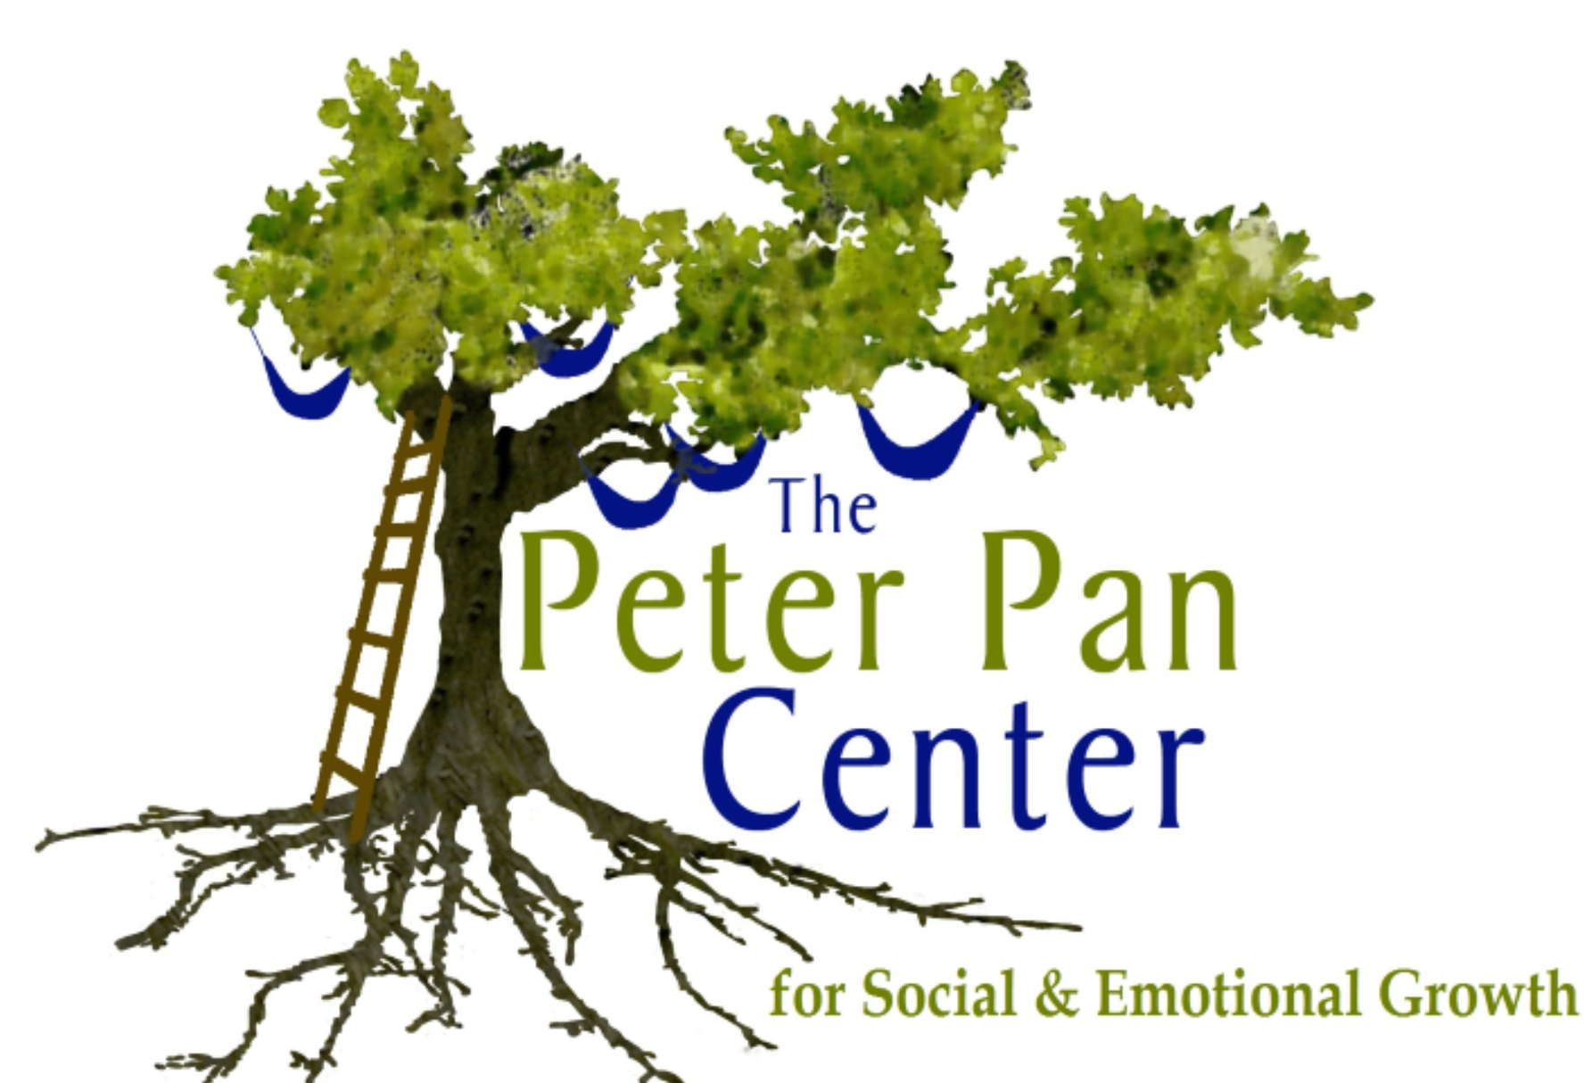
60 Willow Road  Ayer, MA 01432  978/772-1255  www.peterpancenter.com |  |  | Lonnie R. Ouellette, M.A./M.Ed./Cert. BIA  Parent Education/Behavior Specialist  lrouellette.peterpancenter@gmail.com  Cell: 978-314-3647
Registration Form for Social Skills Sessions
Social Teens: (ages 12+) This social skills group is designed for children who are entering middle through high school, and is scheduled in the late afternoon. Social skills addressed through facilitated instruction, and social practice sessions include: recognizing feelings, moods, and emotions, stress, and anxiety; ways to relax, and cope; appropriate social practices, organizational skills, initiating and sustaining social communication, perspective taking, conflict resolution, and problem solving. Session format: 15 minute/Snack Chat; 45 minute Social Group Games; 15 minute/Regroup for Discussion.
Session Schedule: Wednesdays or Thursdays 4:30-5:45
Cost: $45.00 per session/$180.00 per month
Start Date: 9/24/14 or 9/25/14

Parent/Caregiver Name(s):___________________________________________
Child(ren)’s Name(s)/Age(s):__________________________________________
Address:__________________________________________________________
Telephone:______________________Email:_____________________________
Please make checks out to: Lonnie R. Ouellette, and mail to:
The Peter Pan Center Questions? Please email Lonnie at:
PO Box 312 lrouellette.peterpancenter@gmail.com or call
Harvard, MA 01451 978/772/1255
Program Location: The Peter Pan Center, 60 Willow Rd, Ayer, MA 01432

