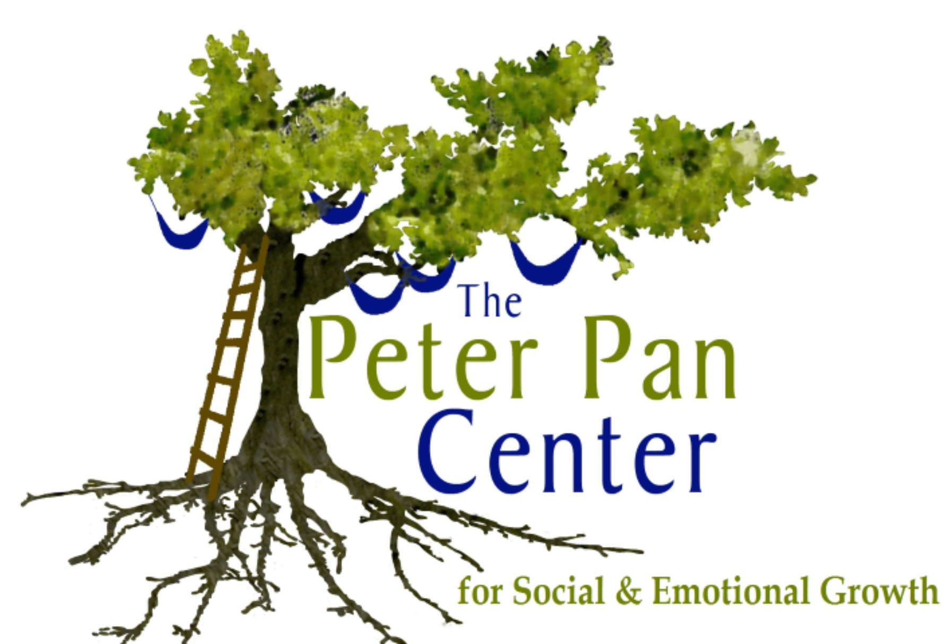The Peter Pan Center
For Social & Emotional Growth
60 Willow Road  Ayer, MA 01432  978/772-1255  www.peterpancenter.com |  |  | Lonnie R. Ouellette, M.A./M.Ed./Cert. BIA  Parent Education/Behavior Specialist  lrouellette.peterpancenter@gmail.com  Cell: 978-314-3647
Registration Form for Social Skills Sessions
Social Seedlings: (ages 3-5) This social skills group is designed for young children, and is scheduled mid-day at lunch time. Parents may drop off their child with a packed lunch or snack. Social skills addressed through facilitated instruction, and play sessions include: developing play skills, group skills (attending, waiting, turn-taking, and follow group directions), socioemotional skills, and developing community social skills. Social skill instruction is conduced weekly for 45 minutes with a 15 minute free play “practice” period during parent pick up at the end of each session.
Session Schedule: Tuesdays 12:00-12:45
Cost: $35.00 per session/$140.00 per month
Start Date: 10/21/2014

Parent/Caregiver Name(s):___________________________________________
Child(ren)’s Name(s)/Age(s):__________________________________________
Address:__________________________________________________________
Telephone:______________________Email:_____________________________
Please make checks out to: Lonnie R. Ouellette, and mail to:
The Peter Pan Center Questions? Please email Lonnie at:
PO Box 312 lrouellette.peterpancenter@gmail.com or call
Harvard, MA 01451 978/772/1255
Program Location: The Peter Pan Center, 60 Willow Rd, Ayer, MA 01432

