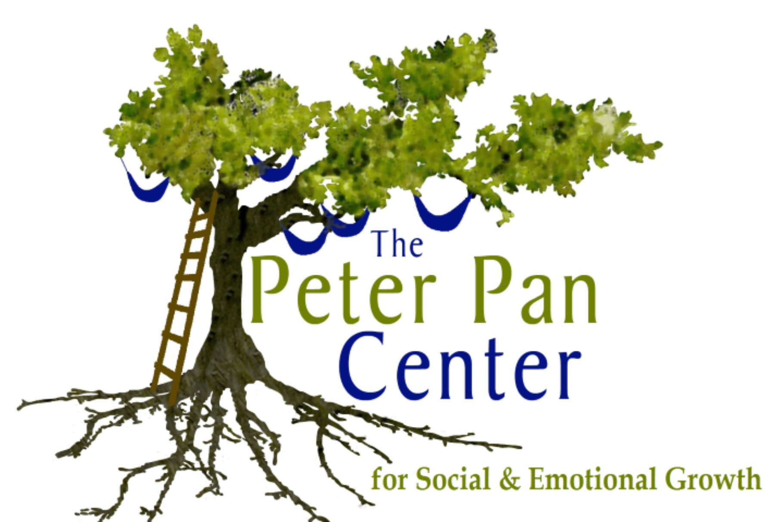The Peter Pan Center
For Social & Emotional Growth
60 Willow Road  Ayer, MA 01432  978/772-1255  www.peterpancenter.com |  |  | Lonnie R. Ouellette, M.A./M.Ed./Cert. BIA  Parent Education/Behavior Specialist  lrouellette.peterpancenter@gmail.com  Cell: 978-314-3647
Registration Form for Social Skills Sessions
Social Saplings: (ages 4-6) This social skills group is designed for children who may have missed the kindergarten cut-off, are in kindergarten or first grade, and is scheduled after school. Social skills addressed through facilitated instruction, and social practice sessions include: developing organization skills, cooperative peer/group play skills, group skills (attending, sharing, and following group directions), socioemotional skills, and developing community social skills. Social skill instruction is conducted weekly for 45 minutes with 15 minute free play “practice” period during parent pick up at the end of each session.
Session Schedule: Thursdays 3:15-4:15
Cost: $35.00 per session/$140.00 per month
Start Date: 10/23/2014

Parent/Caregiver Name(s):___________________________________________
Child(ren)’s Name(s)/Age(s):__________________________________________
Address:__________________________________________________________
Telephone:______________________Email:_____________________________
Please make checks out to: Lonnie R. Ouellette, and mail to:
The Peter Pan Center Questions? Please email Lonnie at:
PO Box 312 lrouellette.peterpancenter@gmail.com or call
Harvard, MA 01451 978/772/1255
Program Location: The Peter Pan Center, 60 Willow Rd, Ayer, MA 01432

