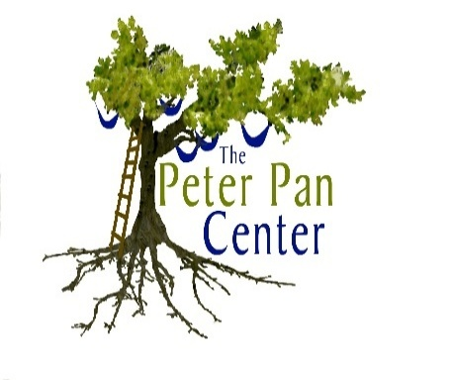
For Social & Emotional Growth
Proudly Presents!
The Early Years Parent Education Series
Designed for Parents/Caregivers of Young Children
Facilitated By:
Lonnie R. Ouellette with Guest Speaker, Donna Shea

6-Week Workshop Schedule  Thursday Evenings  Fall/Spring  9/25/2014 3/5/2015 Ages and Stages of Physical and Language/Cognitive Development.  10/2/2014 3/12/2015 Ages and Stages of Emotional, and Social Development.  10/9/2014 3/19/2015 Your Child’s Behavior: Tips and Tools from the Trenches. (Toddlers-Preschoolers)  10/16/2014 3/26/2015 Your Child’s Behavior: Tips and Tools from the Trenches. (Kindergarten-Grade 2)  10/23/2014 4/2/2015 Schedules, Routines, and Transitions. Using Positive Behavioral Supports for Survival!  10/30/2014 4/9/2015 Let’s Review and Practice!  Parents/caregivers of children with special needs (e.g. Autism, and related developmental disabilities) are encouraged to participate!  Full Series: $240/one parent/caregiver  Full Series: $360/two parent(s)/caregiver(s)  A la Carte Workshops: $45/parent  A la Carte Workshops: $70/both parents  Babysitting is available (reserve ahead)  $10/first child $5/additional children  Workshop Location:  The Peter Pan Center  60 Willow Road  Ayer, MA 01432 | Registration Information  Pre-registration required!  Name: __________________________________________________  Address: ________________________________________________  City, ST, Zip: ____________________________________________  Telephone: _____________________________________________  E-Mail: __________________________________________________  I (we) will be attending (please check/circle date):  - Full series  - Workshop #1 – 9/25/2014 3/5/2015  - Workshop #2 – 10/2/2014 3/12/2015  - Workshop #3 – 10/9/2014 3/19/2015  - Workshop #4 – 10/16/2014 3/26/2015  - Workshop #5 – 10/23/2014 4/2/2015  - Workshop #6 – 10/30/2014 4/9/2015  - Reserve Babysitting - # of children _______  All Workshops are from 6:30-8:00 PM.  Checks should be made out to Lonnie R. Ouellette, and mailed to:  The Peter Pan Center  P.O. Box 312  Harvard, MA 01451  Questions? Please e-mail Lonnie at lrouellette.peterpancenter@gmail.com or call 978/772-1255.

