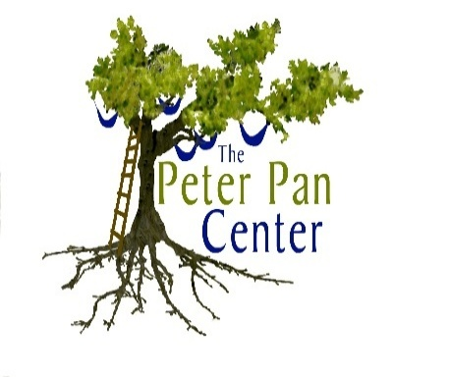
For Social & Emotional Growth

Announcing The Peter Pan Center’s
Branches and Twigs Parenting Program!

This program is designed for parents/caregivers, and their young children (toddlers-preschoolers). Parents/caregivers can attend the Peter Pan Center one morning a week to acquire and practice parenting skills facilitated by Lonnie R. Ouellette (Parent Education Specialist, and Behavioral Consultant), and share resources and ideas with other parents/caregivers to gain support and guidance to promote social and emotional growth for their child(ren). Additional developmental specialists or guest speakers may be invited to share their knowledge, experience and expertise with program participants. Children are invited to attend each session (must be accompanied by their parents/caregivers) to learn and practice social skills during facilitated play sessions. Weekly morning sessions are thematic-based and encompass developmental stages in social, emotional, and behavioral growth. Weekly participation is encouraged. Play sessions are NOT designed with a “drop-in” play group format to provide program continuity, facilitate a network of parenting support, establish trust, foster relationships, and build rapport among program participants. Parents/caregivers of children with special needs (e.g. Autism, and related developmental disabilities) are encouraged to participate! Please complete the Registration Form below!
Branches and Twigs Parenting Program
Registration Information Pre-registration required!
Parent/Caregiver Name(s):___________________________________________
Child(ren)’s Name(s)/Age(s):__________________________________________
Address:__________________________________________________________
Telephone:______________________Email:_____________________________

I (we) will be attending (please check/circle dates) Session Times: 10:00-11:30
Branches and Twigs Session 1: 6 weeks, Tuesdays, 9/23/2014-10/28/2014
Branches and Twigs Session 2: 6 weeks, Tuesdays, 11/4/2014-12/16/2014 (skip 11/11)
Branches and Twigs Session 3: 6 weeks, Tuesdays, 1/6/2015-2/10/2015
Branches and Twigs Session 4: 6 weeks, Tuesdays, 2/24/2015-3/31/2015
Branches and Twigs Session 5: 6 weeks, Tuesdays, 4/7/2015-5/19/2015 (skip 4/21)
Cost: $45.00 per class/$255.00 per 6 week sessions includes snack, crafts supplies, etc.
Please make checks out to: Lonnie R. Ouellette, and mail to:
The Peter Pan Center Questions? Please email Lonnie at:
PO Box 312 lrouellette.peterpancenter@gmail.com or call
Harvard, MA 01451 978/772/1255
Program Location: The Peter Pan Center, 60 Willow Rd, Ayer, MA 01432

